Lancashire Enterprise Partnership Limited

Private and Confidential: NO

Date: Wednesday, 1 May 2019

Lancashire Digital Skills Partnership: Progress, Digital Skills Innovation Fund and the Tech Talent Charter
(Appendix 'A' refers)

Report Author: Dr Michele Lawty-Jones, Director of the Lancashire Skills Hub and Kerry L. O. Harrison, Digital Skills Coordinator, Kerry.harrison@lancashirelep.co.uk

Executive Summary

This paper provides an overview of the development of the Lancashire Digital Skills Partnership that was launched in April last year. The partnership was the first to launch in England. In November, the Digital Skills Coordinator was appointed and the Network Groups established that feed into the Digital Skills Partnership Steering Group.
The paper includes details of the Digital Skills Innovation Fund (DSIF), awarded to the Lancashire Enterprise Partnership in March 2019, and recommends a process for approving associated project business cases. In addition, the paper provides an overview of the Tech Talent Charter and recommends that the LDSP / LEP sign up to the charter with view to advocating diversity across the Tech Sector in Lancashire.
The paper also provides an overview of example activities aligned with each of the strategic themes of the Lancashire Skills and Employment Strategic Framework – Future Workforce, Skilled and Productive Workforce, Inclusive Workforce and Informed Approach.

Recommendation

The Lancashire Enterprise Partnership Board is asked to:

- Note progress.

- Delegate authority to the interim Chief Executive, in consultation with the Section 151 Officer, to sign off the DSIF business cases as appropriate and agree and approve the entering into of grant funding agreements; and
- Approve the signing of the Tech Talent Charter.

Background and advice

  - In the Digital Strategy, published in March 2017, the Government set out its commitment to improving the digital skills capabilities of individuals and organisations across England. It was recognised that a partnership approach was required to drive up digital skills. As a result the Government announced the formation of a National Digital Skills Partnership bringing together public, private and charity sectors and key regional stakeholders to develop a more collaborative, coordinated and innovative approach to meeting the digital skills challenge.

  - The Industrial Strategy, published in November 2017, referenced the establishment of Local Digital Skills Partnerships (LDSP) to increase collaboration between public, private and charity sector organisations and help address local digital skills needs in more targeted and innovative ways in local areas.

  - The Department for Digital, Culture, Media and Sport (DCMS) has established the National Digital Skills Partnership, and is leading on supporting the development of pilot LDSPs across the country.

  - Lancashire had already identified a need for action across the digital skills agenda and had started to embed this into the Lancashire Skills and Employment Strategic Framework. This strategic planning and linked activity lead to a successful bid to be a LDSP pilot. The Lancashire DSP was the first pilot to be launched in England, at the Lancashire Digital Skills Summit, held at EKM in Preston, in April 2018. DCMS awarded a grant of £75k to enable the appointment of a Digital Skills Partnership Coordinator for 12 months. The Coordinator will drive activity locally and also meet regularly with DCMS and Coordinators from other areas to support the roll out of LDSPs across the Country. Kerry Harrison was appointed to the Coordinator role and commenced employment in November 2018.

  - Since the launch, two further pilots have been launched in the West Midlands and the Heart of the South West. A further 3 LDSPs will be formally launched during May and June in Cornwall and the Isles of Scilly, Cheshire and Warrington and the South East.

2.0 Governance and Networks
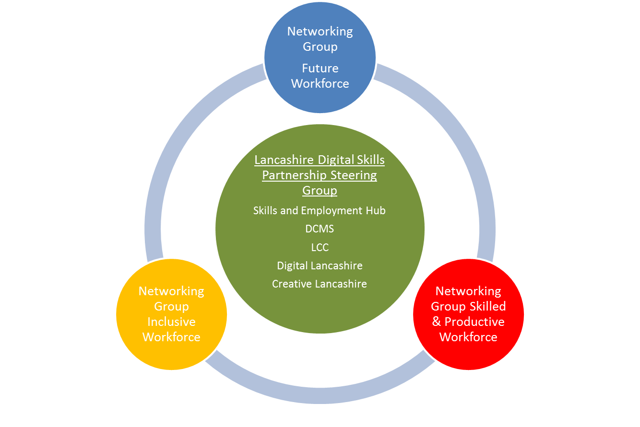
Figure 1 – Structure of the Lancashire Digital Skills Partnership

- A Steering Group for the Lancashire DSP has been established, chaired by Mike Blackburn, LEP Board Director, which reports to the Skills and Employment Advisory Panel. The Steering Group has met bi-monthly since June 2018.

- Networking groups have been established to mirror the strategic themes in the Lancashire Skills and Employment Strategic Framework, to drive activity and a joined up approach to identifying and addressing digital skills needs and gaps. The Future Networking Group and Skilled and Productive Workforce Networking Groups launched at the end of January. Both were well attended and feedback was positive, for example: "everyone round the table seems on board, listening to the issues faced by the different areas; useful network/partnership; good to learn about initiatives happening currently and aspirations for the group; great to meet people, hear about initiatives and the journey so far".

- These two Networking Groups agreed to meet quarterly and will rotate location around the County allowing opportunities to show case locations such as Strawberry Fields, Chorley. The Inclusive Workforce Networking Group sits within the Adult Skills Forum, and digital skills is embedded into the agenda.

- DCMS supports the partnership through the Regional Coordinators including weekly phone calls and monthly face to face meetings at Whitehall. The meetings provide opportunity to share good practice and lessons learnt with other LDSPs.

- The Communications Lead for the digital team of the DCMS has been appointed to coordinate activity showcasing different aspects of all the LDSPs. This has included a schedule of blogs published on the DSP website. These started with an introduction to the Regional Coordinators:
https://digitalskillspartnership.blog.gov.uk/2019/02/26/introducing-the-dsps-regional-coordinators-kerry-harrison-lancashire/ and a follow up blog on the work of the Lancashire DSP with National Partners:
https://digitalskillspartnership.blog.gov.uk/2019/03/06/the-work-of-lancashires-digital-skills-partnership/.

A Lancashire focused Freeformers blog being jointly written by Laura Myers - Lancashire Adult Learning, Kerry Harrison and Freeformers has also been published: https://digitalskillspartnership.blog.gov.uk/2019/03/21/digital-skills-training-in-partnership-with-facebook-and-freeformers-in-lancashire/.

- A new DSP logo has been produced by the DCMS team and we are encouraging all partners to use the logo to raise awareness of the partnership.

- The diagram attached (Appendix 'A') provides an overview of a number of activities undertaken to date through the Lancashire Digital Skills Partnership, in-line with the strategic themes in the Lancashire Skills and Employment Strategic Framework, demonstrating the added value of the partnership to-date.

- The digital skills research which has been commissioned under Informed Approach will provide an updated baseline, which will be used to assess and track digital skills levels and needs across the Lancashire area. The research will also be fed into the evidence base for the Local Industrial Strategy.
- Digital Skills Innovation Fund (DSIF)

- The purpose of the DCMS Digital Skills Innovation Fund is to pilot or scale up innovative programmes that aim to address local or regional digital challenges while supporting people from underrepresented groups and/ or disadvantaged backgrounds into digital roles.

- The fund was launched in August 2018 by DCMS and was targeted at Mayoral Combined Authorities and Local Enterprise Partnerships.

- A proposal was developed with partners in Lancashire and submitted by the deadline in October 2018, following approval from the LEP Executive Committee. The process involved the following steps:
- The Skills and Employment Hub invited proposals from members of the Digital Skills Partnership (c60 members including employers, providers and stakeholders) referencing priorities identified in the Skills and Employment Hub evidence base, the Lancashire Skills and Employment Strategic Framework and the criteria set out by DCMS in the specification.
- A total of 6 projects were put forward by partners, which were assessed by the Hub against the criteria and strategic priorities. One project was under-developed and did not have the necessary match funding and one did not align with the criteria in the specification and so four projects were included in the submission from Lancashire.
- The final submission was approved by the LEP Executive Committee on 25th October 2018.

- Lancashire is one of 4 areas in the Country to successfully secure Digital Skills Innovation Funds (DSIF). Official announcement of the fund was made on Friday 15th March and reported at the last Board meeting.

- In terms of the submission, of the four projects, DCMS deemed one project ineligible due to fit with the criteria, as the project was targeted at increasing the pipeline of digital talent in schools and colleges, rather than supporting underrepresented groups to access digital roles and to develop their skills – the project was deemed too far away from the workplace.

- A grant determination letter was thus issued at the end of March for £274,000, for the three remaining projects, for spend over the coming two financial years. The projects are subject to full business cases and due diligence. The projects aim to support unemployed, disadvantaged and underrepresented residents into digital roles and support self-employed females and females in the workplace to develop their digital skills. Further details of the projects are provided below.

- IT-Ready enables employers to access fresh talent with modern IT Infrastructure skills and aims to support disadvantaged and underrepresented residents into digital jobs. IT-Ready is designed around the CompTIA A+ industry standard for professional entry-level jobs such as Analyst, IT Support and Technician. Graduates have an opportunity to train towards the CompTIA Network+ and CompTIA Security+ certifications as well as gain sustainable employment which addresses local skills gaps.

- Digital Marketer's focus is to deliver basic website building courses using WordPress. Participants will work towards the City & Guilds Level 1 ‘website software’ unit. Participants would then progress to further learning, including the Level 3 Apprenticeship standard 'Digital Marketer' and employment in the digital industry alongside the provider's recruitment agency, with a view to securing sustainable employment in digital roles.

- Women's Digital Business Skills focuses on enhancing the digital skills of females who are employed in small to medium enterprises or self-employed, with view to enhancing digital skills to support the individual's career development and the development and growth of existing businesses in Lancashire.

- In-line with guidance from legal, partners leading the projects have been asked to submit full business cases by the 26th April for appraisal by the Hub team and sign off as appropriate. Subject to the outcome of the appraisal, partners will be provided with a grant funding agreement which they will be required to enter into before any funds are released; it is anticipated that grant funding agreements can be issued in May to enable delivery to commence in June. This will give partners an 18 month delivery period, followed by a quarter for evaluation.

- Recommendation: The LEP Board are asked to delegate authority to the Chief Executive, in consultation with the Section 151 Officer, to sign off the full project business cases (which are subject to appraisal by the Hub team) where it is considered appropriate to do so and thereafter to agree and approve the entering into of a grant funding agreement.

4.0 Tech Talent Charter

  - Tech Talent Charter (TTC) is supported by the Government in the UK Digital Strategy. DCMS support the Tech Talent Charter, as one of a number of measures aimed at addressing the gender diversity gap.

  - The Government announced in February 2018 that all Government departments would be signing up to the Charter. In January 2019, Margot James issued a call to all employers to join the TTC. DCMS are keen for the LDSPs to engage and become advocates for the charter and champion to partners within the Tech sector.

  - The TTC is a commitment by organisations to a set of undertakings that aim to deliver greater gender diversity in the Tech Workforce of the UK. Signatories of the charter make several pledges in relation to their approach to recruitment and retention and to work together to move the dial on diversity.

  - TTC suggest benefits to signatories include:
- A chance to be a leading force in driving diversity in the sector for the UK.
- Access to sector leading insights, programmes, initiatives, best of breed practices to improve diversity and inclusion across the entire talent pipeline.
- Access to sector-wide benchmarking data to understand your company’s position across a range of indicators in relation to diversity.
- Opportunities to attend or to take leadership positions at events when some of the sectors most challenging HR problems are discussed and solutions shared.
- Opportunities for thought leadership to assist with brand perception and to aid recruitment.
  - The TTC is looking to work in closer partnership with LEPs and LDSPs to map existing provision, to gather and share best practice and to support the growth of joined up work on improving diversity at a local and regional level.

  - If the Lancashire LEP/Digital Skills Partnership sign the charter, TTC aim to work closely with us to promote the charter and help businesses to develop good practice in recruitment and retention. Signatory would therefore be focused on promoting diversity in the Tech Sector in Lancashire.

  - Recommendation: It is recommended that the LEP sign up to the TTC, to enable the Lancashire Digital Skills Partnership to act as an advocate and encourage local organisations in the Tech Sector to sign up, to drive diversity in the Tech Sector locally.

List of Background Papers

Paper | Date | Contact/Tel
N/A

Reason for inclusion in Part II, if appropriate

N/A

